**DAILY ONLINE ACTIVITIES SUMMARY**

|  |  |  |  |  |  |  |  |
| --- | --- | --- | --- | --- | --- | --- | --- |
| **Date:** | **25//06/2020** | | | | **Name:** | **Syed Rabeya Aamir** | |
| **Sem & Sec** | **8th B** | | | | **USN:** | **4AL16CS112** | |
| Online Test Summary | | | | | | | |
| **Subject** | | **SMS** | | | | | |
| **Max. Marks** | | **30** | | **Score** | | **---** | |
| Certification Course Summary | | | | | | | |
| **Course** | **Exam Readiness: AWS Certified Solutions Architect – Associate (Digital).** | | | | | | |
| **Certificate Provider** | | | **Aws** | **Duration** | | | **2 hrs** |
| Coding Challenges | | | | | | | |
| **Problem Statement:**  **1)**  Python program to find sum in Nth group and Check if given array is Monotonic. | | | | | | | |
| **Status: Solved** | | | | | | | |
| **Uploaded the report in Github** | | | | **YES** | | | |
| **If yes Repository name** | | | | **rabeya** | | | |
| **Uploaded the report in slack** | | | | **YES** | | | |

**Certification Course Details:**

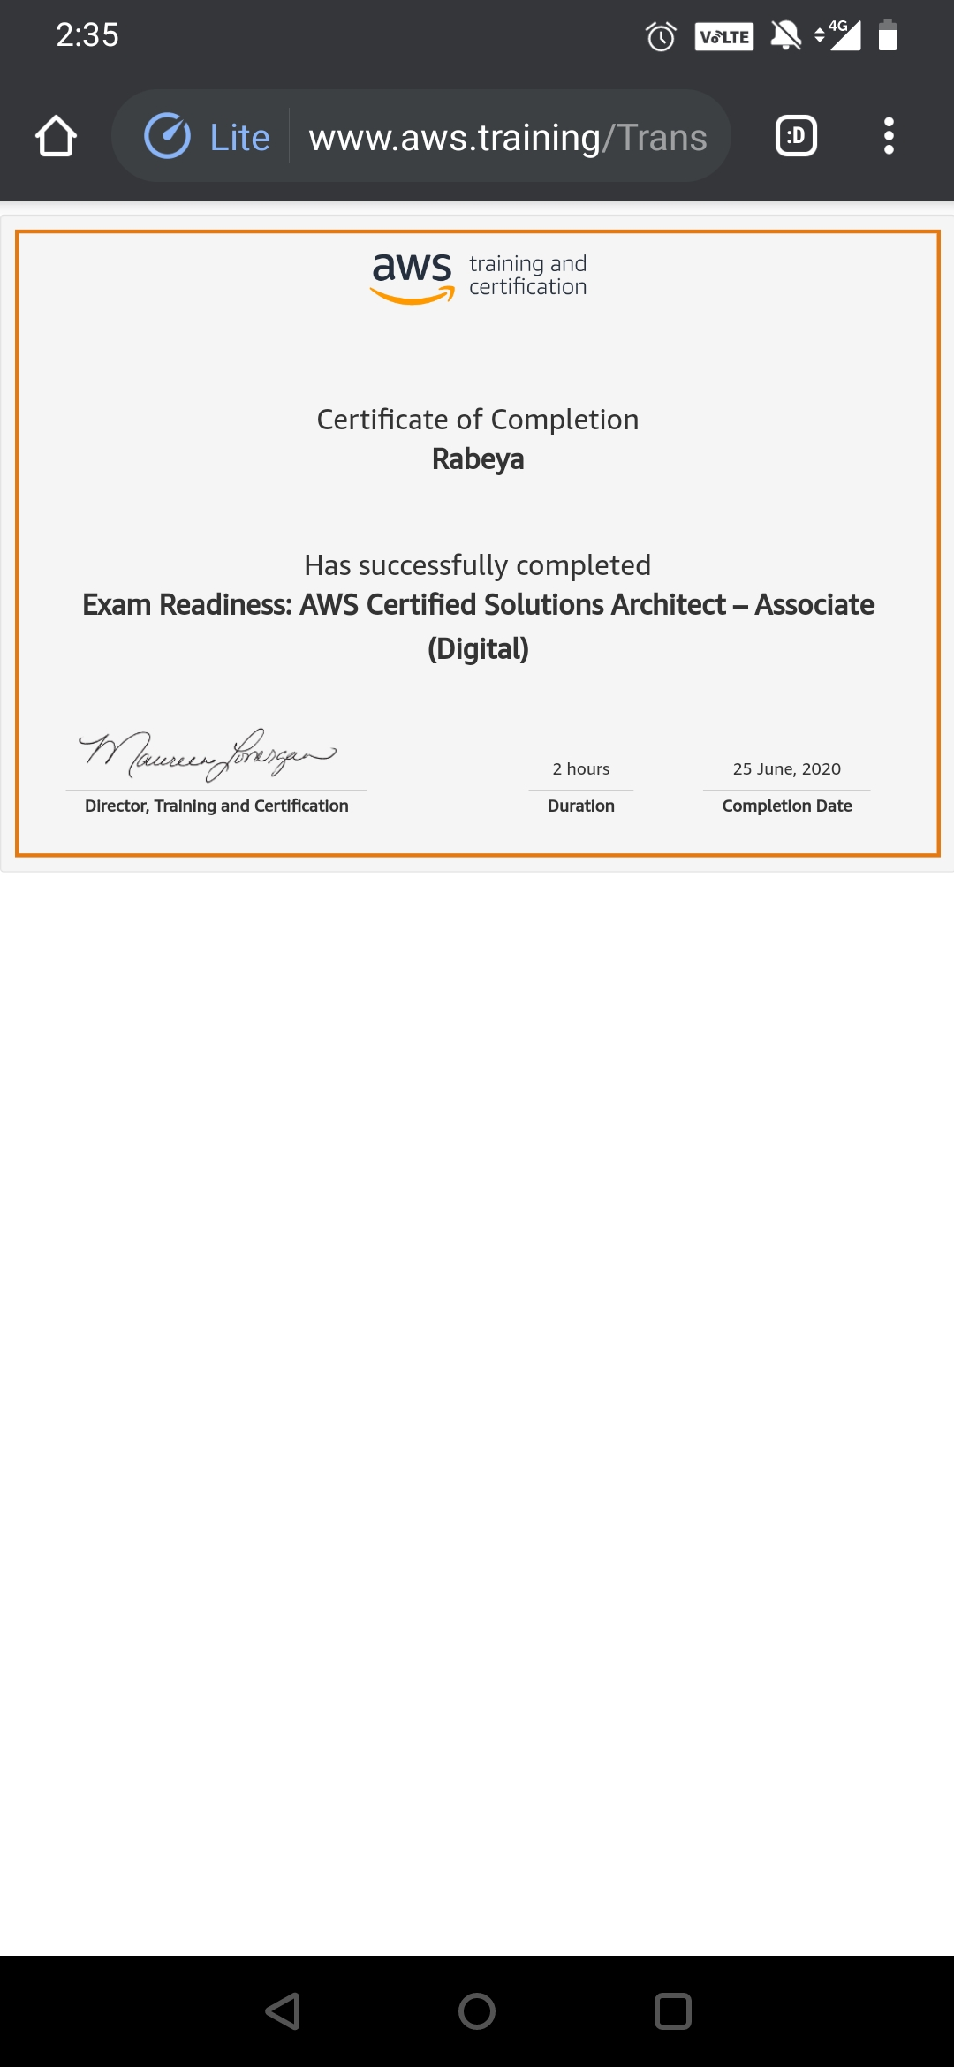

# CODE:

Program no:1

#Python program to find sum in Nth group and Check if given array is Monotonic

def isMonotonic(A):

return (all(A[i] <= A[i + 1] for i in range(len(A) - 1)) or

all(A[i] >= A[i + 1] for i in range(len(A) - 1)))

# Driver program

A = [6, 5, 4, 4]

# Print required result

print(isMonotonic(A))